**RESUME**

**T.Vigneswari**  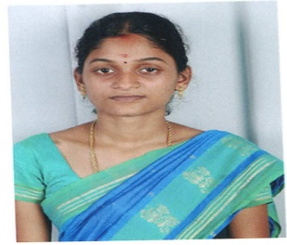  **Door no: 39,**

**North street,**

**panchatcharapuram,**

**nedungadu.**

[**tevinayak@gmail.com**](mailto:tevinayak@gmail.com)

**Mob: 7598909505, 8667063461**

|  |
| --- |
|  |

**CAREER OBJECTIVE:**

I wish to work in a progressive environment which gives opportunity to utilize my skills, to meet challenges, succeed in the same through my hard work, preserverence and unique approach.

**KEY SKILLS:**

* Create and design projects from consumption to end product.
* Team player and leader.
* Professional and effective and verbal communication.
* Graphic design and technical skills

**PERSONAL INFORMATION:**

* Comprehensive problem solving abilities.
* Ability to think positive in problematic environment.
* To strive hard to attain the goal.
* A good self learner.

**PERSONAL PROFILE:**

Name : T.vigneswari

Father name : N.Tamilvanan

Mother name : T.vijayalakshmi

Husband name : R.selvam

D.o.B : 2-3-1991

Age : 27

Gender : Female

Marital status ; Married

Nationality : Indian

Religion : Hindu

Languages known : Tamil, English

**Educational qualification:**

|  |  |  |
| --- | --- | --- |
| Qualification | Instituition | Percentage |
| M.A English | E.G.S.Pillay college of arts and science,nagapattinam | Pursuing 4th sem |
| M.sc.computer science) | E.G.S.pillay college of arts and science  Nagapattinam | 65.% |
| H.S.C | Annai teresa govt.girls hr.sec.school,karaikal | 63% |
| S.S.L.C | Nirmala ranee girls hr.sec.school | 69.4% |

**Additional qualification:**

Typewriting : lower(English)

Course : D.C.A

**Experience:**

Worked as a Project Co-Ordinator in Media Assist India Pvt at Karaikal

Worked as a spoken English trainer in Gandhi institute under Ongc.And also conducted soft skill programs to additional personality development class.(2014 to 2017)

Working as a English teacher cum spoken English and soft skill trainer at Adarsh Concept school,kottucherry.

**Extracurricular activities**:

NCC, NSS

**Languages known:**

C, C++, java

**Packages known**

MS-Office

**Project:**

SQL engine for oracle

This project proposes a new technique, SQL injection projector for authentication, for preventing database against SQL injection.

**Declaration**

I hereby declare that the above mentioned information are true and correct to the best of my knowledge.

Place:karaikal yours truthfully,

Date: T.vigneswari.